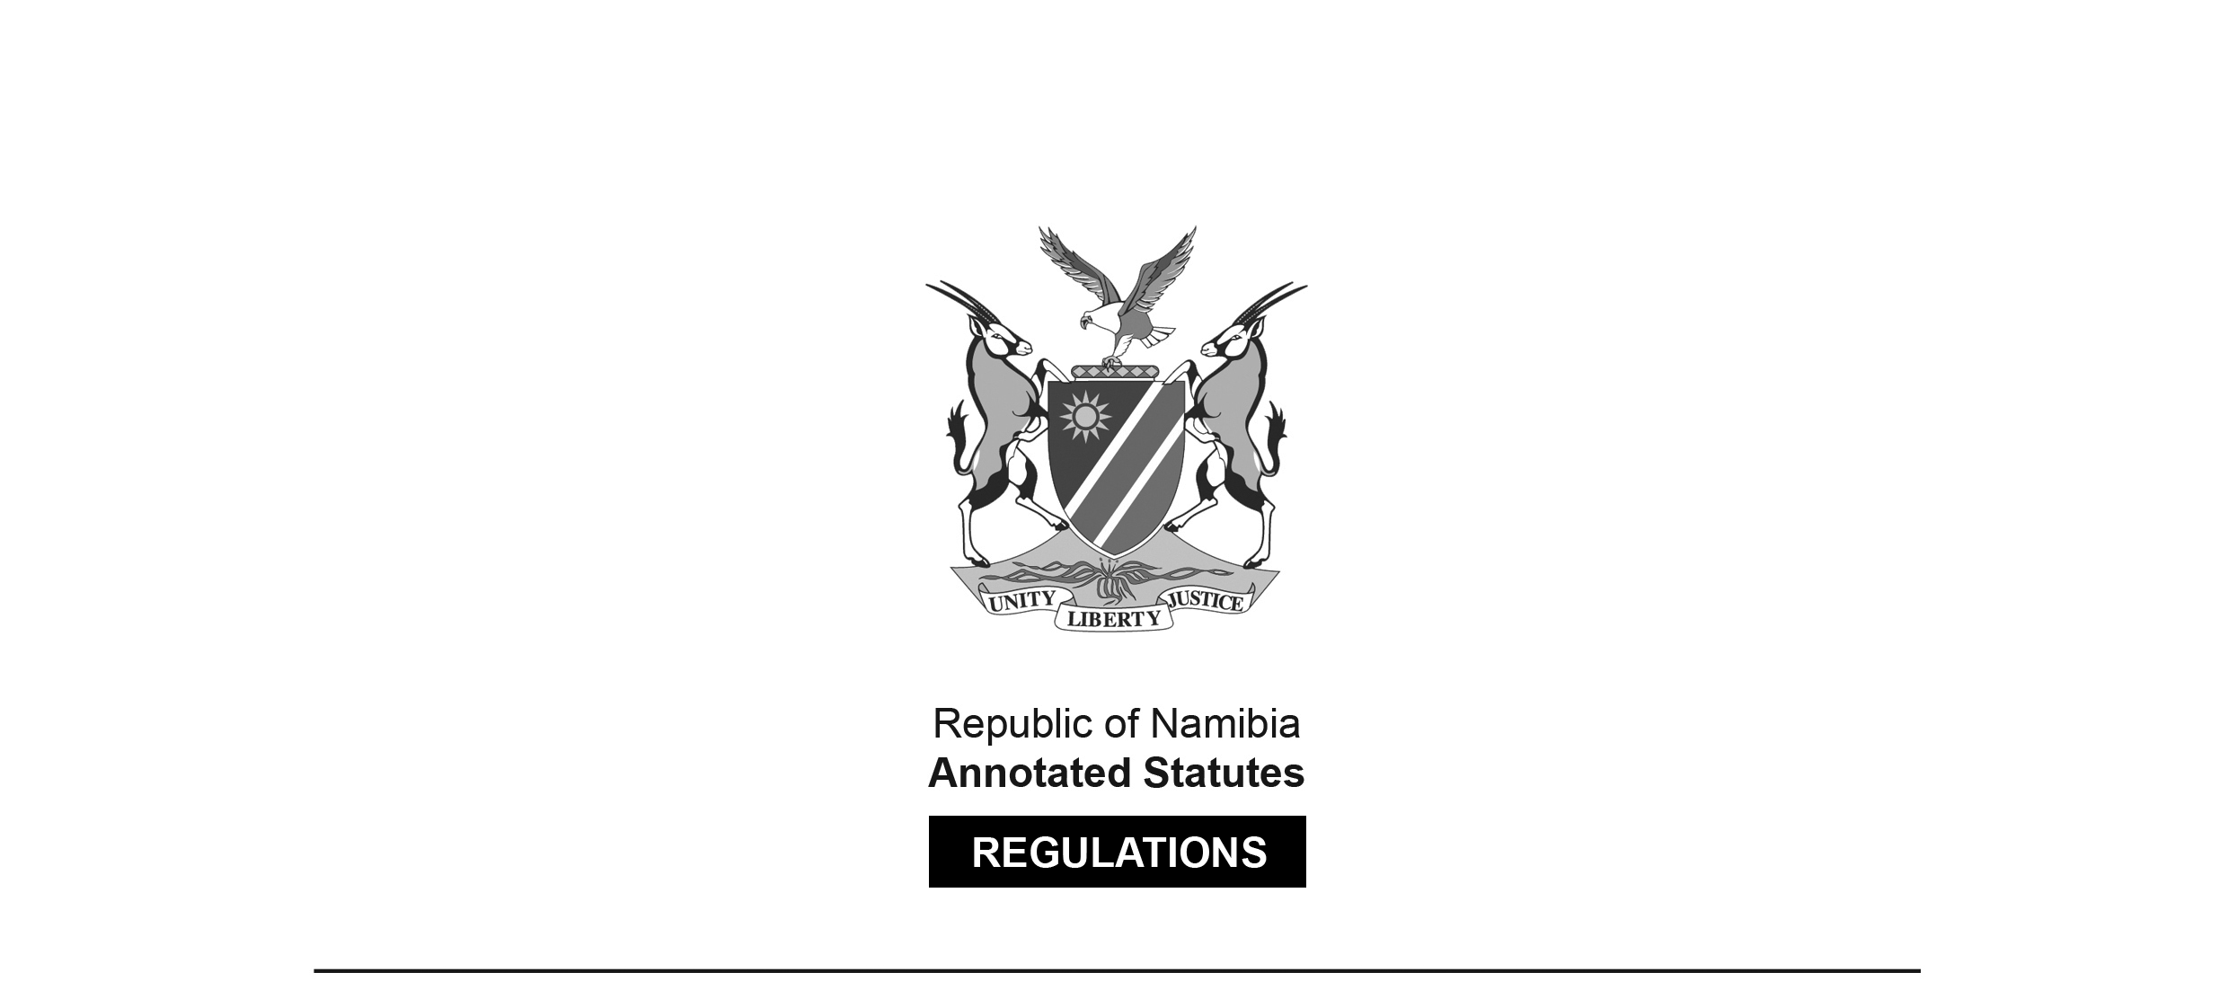

REGULATIONS SURVIVING IN TERMS OF

Health Professions Act 16 of 2024

section 95(10)

Regulations relating to the Qualifications entitling Dentists to Register, Minimum Curriculum for Dentistry and Professional Examinations for Dentists

Government Notice 51 of 2006

([GG 3595](http://www.lac.org.na/laws/2006/3595.pdf))

came into force on date of publication: 20 February 2006

These regulations were made in terms of section 59 of the Medical and Dental Act 10 of 2004, which was repealed by the Health Professions Act 16 of 2024. Pursuant to section 95(10) of the Health Professions Act 16 of 2024, they are deemed to have been made under that Act.

The Government Notice which publishes these regulations notes that they were made   
on the recommendation of the Interim Medical and Dental Council.

ARRANGEMENT OF REGULATIONS

1. Definitions

2. Minimum requirements for registration as a dentist

3. Minimum requirements for study at educational institution

4. Examinations by educational institution

ANNEXURE: Minimum Curriculum for Dentistry

**Definitions**

**1.** In these regulations, unless the context otherwise indicates, a word or expression defined in the Act has that meaning, and -

“Council” means the Interim Medical and Dental Council of Namibia established under section 63 of the Act or the Medical and Dental Council of Namibia established by section 3 of the Act, as the case may be;

“student” means a person registered as a student in dentistry at an educational institution and who is receiving the training and tuition in dentistry specified in these regulations; and

“the Act” means the Medical and Dental Act, 2004 (Act No. 10 of 2004).

**[The** Medical and Dental Act **10 of 2004   
has been replaced by the Health Professions Act 16 of 2024.]**

**Minimum requirements for registration as a dentist**

**2.** (1) The minimum qualification which, in terms of section 18(1) of the Act, entitles the holder to registration with the Council as a dentist is the Bachelors Degree in Dental Science and Surgery granted by an educational institution.

(2) The qualification referred to in subregulation (1) may only be recognised if -

(a) the dental course consisted of at least five years of full time academic study at an educational institution or educational institutions;

(b) the dental course included the passing of the subjects specified in the Annexure; and

(c) the curriculum of study of the educational institution which granted the qualification meets the requirements specified in regulations 3 and 4.

(3) In addition to possessing the qualification specified in subregulation (1), the person who seeks registration with the Council must comply with all the other requirements prescribed by or under the Act, including the passing of an evaluation conducted by the Council in accordance with section 20(3) of the Act.

**Minimum requirements for study at educational institution**

**3.** (1) The minimum curriculum of study for an educational institution referred to in regulation 2(1) must meet the minimum requirements set out in this regulation.

(2) The educational institution must, during the period of study referred to in regulation 2(2)(a) and throughout the entire curriculum, provide for adequate arrangements relating to the effective co-ordination of the various subjects specified in the Annexure.

(3) All the subjects referred to in the Annexure must be directed, as from the first year of study, at the tuition and training in dentistry.

(4) The tuition and training by the educational institution in the basic subjects of Anatomy, Physiology, Pathology and Pharmacology, as applicable to the clinical practice of a dentist, must be continued throughout the entire period of study referred to in regulation 2(2)(a).

(5) The curriculum referred to in subregulation (2) must consist of systematic training and tuition and practical work, and must cover a basic syllabus consisting of the subjects specified in the Annexure.

(6) The educational institution must integrate the various subjects specified in the Annexure relating to their clinical application.

**Examinations by educational institution**

**4.** (1) The examinations referred to in this regulation may be conducted by the educational institution in part by means of the continual evaluation of the student.

(2) The examinations relating to a qualification referred to in regulation 2(1) -

(a) must include examinations in all of the subjects specified in the Annexure; and

(b) may be conducted in an integrated manner according to the requirements of the relevant faculty of the educational institution.

(3) The examination team which conducts the examinations in the final year of study of each subject specified in the Annexure, must include external examiners.

(4) Not less than two examiners, of whom one must be an external examiner not involved in the tuition or training of the student, must take part in the conducting of the examination of the student referred to in the Annexure.

(5) The external examiner referred to in subregulation (4) need not be present during the entire examination, nor need he or she have to mark every examination paper, of the student.

(6) A student must be deemed to have passed the examination if he or she has obtained not less than 50 percent of the maximum marks that can be obtained in the examination, or the equivalent of 50 percent of the maximum marks in the marking system employed by the educational institution.

(7) Subregulation (6) applies to both the clinical or practical part and the theoretical part of the examinations.

(8) The examiners referred to in subregulation (4) must take into account, in order to ensure the continued evaluation of a student, the documented records of the work done by a student throughout the course of study, including work done in optional subjects and projects.

(9) The final academic examinations conducted by the examiners referred to in subregulation (4) must be so conducted in respect of all the main clinical subjects.

ANNEXURE

**Minimum curriculum for dentistry**

**1.** The minimum curriculum for the purpose of obtaining the qualification contemplated in regulation 2(1), must include the following subjects:

|  |  |
| --- | --- |
| **SUBJECT** | **TOTAL HOURS OF TUITION AND TRAINING** |
| (a) Chemistry, including Science and World Views: | 220 |
| (b) Physics: | 160 |
| (c) People and their environment: | 460 |
| (d) Human Anatomy, including Medical Terminology and Dissection: | 410 |
| (e) Homeostase, including Human Physiology (applied) and Biochemistry: | 520 |
| (f) Human Histology and Cell Biology: Molecular and Cell Biology, Molecule to Organism: | 560 |
| (g) Pharmacology: Introduction to Pharmacology, Clinical Pharmacology and Generic Procedural Skills: | 180 |
| (h) Pathology: | 450 |
| (i) Practice Management: | 220 |
| (j) Maxillo Facial and Oral Surgery Applied Head and Neck Anatomy, Oro-facial Surgery: | 1070 |
| (k) Orthodontics: Dentofacial Anomalies: | 490 |
| (l) Radiography: | 80 |
| (m) Oral Medicine and Periodontics: Periodontology and Clinical Oral Medicine: | 370 |
| (n) Prosthetic Dentistry, restricted to Removable Dentures: | 930 |
| (o) Community Dentistry: | 100 |
| (p) Oral Biology: | 110 |
| (q) Maxillo Facial Pathology: | 320 |
| (r) Clinical Dentistry: Introduction to Clinical Medicine and Comprehensive Patient Care: | 290 |
| (s) Basic Emergency Care: | 50 |
| (t) Odontology: Conservative (Restorative) Dentistry, including Applied Medicine and the Science of Dental Biomaterials: | 1810 |

**2. The subjects specified in item 1 are subject to the following conditions:**

(a) the tuition and training in such subjects are presented by the educational institution in such a manner that instruction in the basic principles which are required in the subsequent study of all the disciplines of the dental curriculum, including practical instruction therein, are included in such tuition and training;

(b) the tuition and training in the clinical and practical dental subjects must be presented, in respect of every such subject, over a minimum period of two consecutive years, and must include preventive, promotive, curative and rehabilitative elements relating to such subjects; and

(c) the educational institution must ensure that the tuition and training programme relating to such subjects is co-ordinated in an orderly manner.